**HOVER & ACTIVE**

<!DOCTYPE html>

<html>

<head>

<title>Hover & Active</title>

<style>

border-radius:5 px;

margin:5 px;

padding:8 px;

a:active {

background-color: red;

}

img:hover{

border: 2px solid red;

}

</style>

</head>

<body>

<h1>Mr.Bean</h1>

<img src="E:\Software Testing/cartoon.png"><br>

<a href="https://www.instagram.com/mrbean/?hl=en">Catch me on Instagram</a><br>

<a href="https://www.pinterest.com/pin/mr-bean-png-image-purepng--693695148841223117/">Catch me on Pinterst</a><br>

</body>

</html>

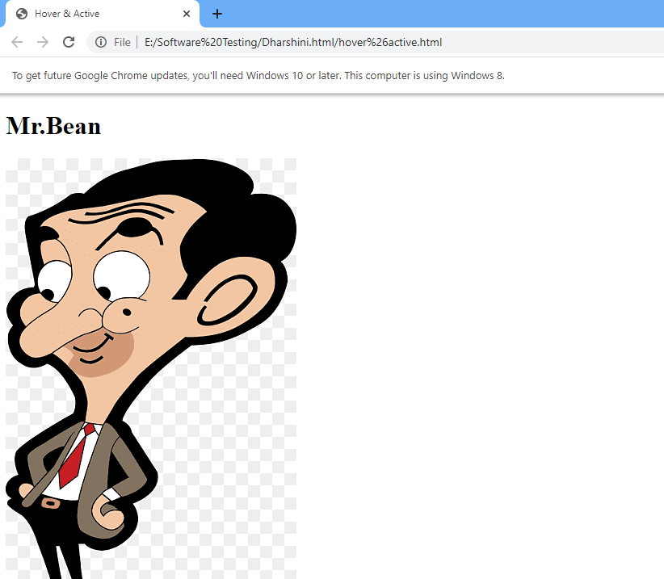

**JAVASCRIPT REGULAR EXPRESSIONS**

<!DOCTYPE html>

<html>

<body>

<h2>JavaScript Regular Expressions</h2>

<p>Do a global search for that characters that are not "h":</p>

<p id="demo"></p>

<script>

let text = "Is this all there is?";

let pattern = /[^h]/g;

let value = /[h]/g;

let result = text.match(pattern);

let output = text.match(value);

document.getElementById("demo").innerHTML = result;

</script>

</body>

</html>

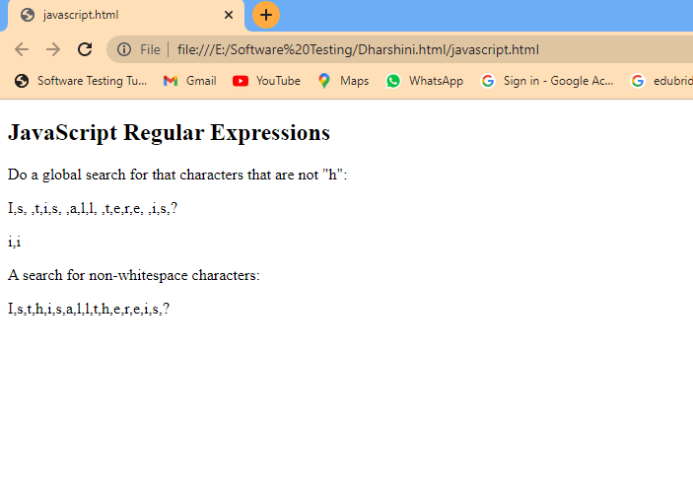

**JAVASCRIPT CLOCK**

<!DOCTYPE html>

<html>

<body onload="startTime()">

<h2>JavaScript Clock</h2>

<div id="Time"></div>

<script>

function startTime() {

const today = new Date();

let h = today.getHours();

let m = today.getMinutes();

let s = today.getSeconds();

m = checkTime(m);

s = checkTime(s);

document.getElementById('Time').innerHTML = h + ":" + m + ":" + s;

setTimeout(startTime, 1000);

}

function checkTime(i) {

if (i < 10) {i = "0" + i}; // add zero in front of numbers < 10

return i;

}

</script>

</body>

</html>

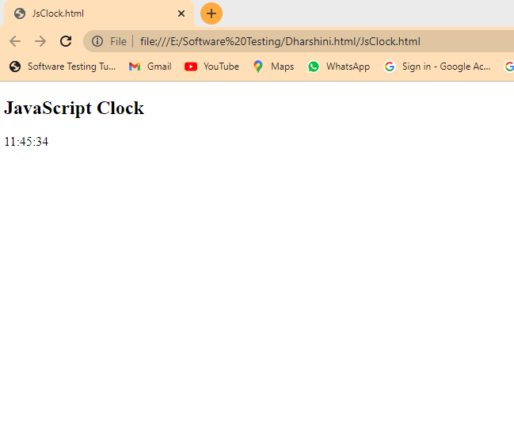

**REGULAR EXPRESSION WITH CASE-INSENSITIVE**

<!DOCTYPE html>

<html>

<body style="background-color:powderblue;">

<h2>JavaScript Numbers</h2>

<script>

const text = 'Hello, hello, HELLO!';

// Regular expression with 'g' (global) and 'i' (case-insensitive) flags

const regex = /hello/gi;

// Matching the regular expression against the text

const matches = text.match(regex);

console.log(matches);

</script>

<script>

const text = 'The quick brown fox jumps over the lazy dog';

// Regular expression using brackets to match a range of characters

const regex = /[a-f]/gi;

// Matching the regular expression against the text

const matches = text.match(regex);

console.log(matches); //

</script>

</body>

</html>

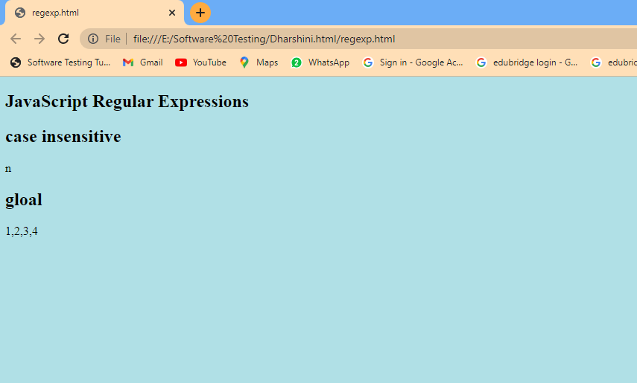

**SET DATE**

<!DOCTYPE html>

<html>

<body style="background-color:powderblue;">

<h2>JavaScript Dates</h2>

<p>setDate() sets the day of the month of a date:</p>

<p id="demo"></p>

<script>

const d = new Date("Aug 3,2002 01:15:00");

d.setDate(20);

document.getElementById("demo").innerHTML = d;

</script>

</body>

</html>

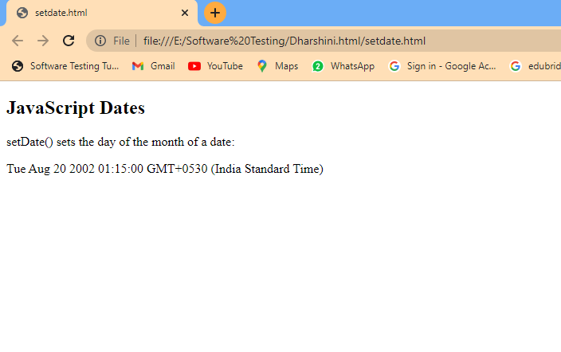

**TABLETAG**

<!DOCTYPE html>

<html>

<head>

<title>tableTag</title>

<style>

table,th,td

{

border:2px solid black;

border-radius: 3px;

background-color: azure;

padding: 8px;

}

</style>

</head>

<body>

<h2>Names</h2>

<table border="3">

<tr>

<th>Name</th>

<th>Age</th>

<th>City</th>

<th>Degree</th><tr>

</tr>

</tr>

<tr>

<td>John</td>

<td>30</td>

<td>New York</td>

<td>BCA</td>

</tr>

<tr>

<td>Alice</td>

<td>25</td>

<td>Los Angeles</td>

<td>Bsc(cs)</td>

</tr>

<tr>

<td>Bob</td>

<td>35</td>

<td>Chicago</td>

<td>BE</td>

</tr>

<tr>

<td>Riyaz</td>

<td>30</td>

<td>Washionton</td>

<td>BE ECE</td>

</tr>

<tr>

<td>Fazil</td>

<td>25</td>

<td>Chicago</td>

<td>Fashiontech</td>

</tr>

</table>

</body>

</html>

